**CURSORS**

1.Calculate Interest for Fixed Deposit Amount Using Cursors.

Set intrest as 0 and then update it using the program.

Set 10% intrest for amount less than or equal to 1000.

20% for more then 1000 to 5000.

30% for above 5000.

**Program**

create table fd(accno int primary key,year int,amount int,interest int);

insert into fd values(&accno,&year,&amount,&interest);

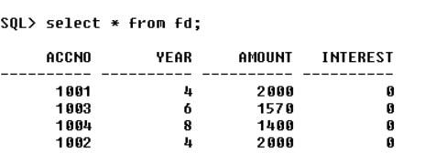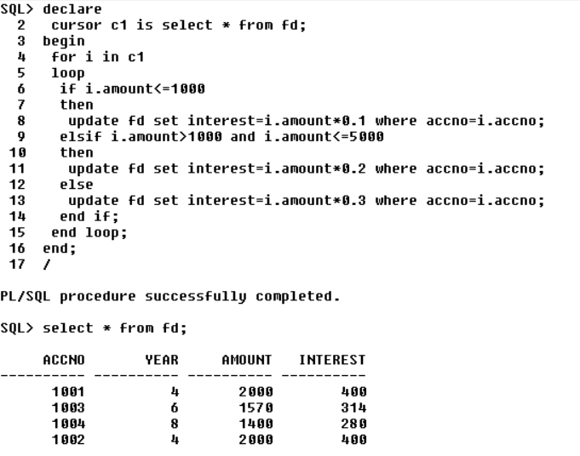

**Output**



1. Calculate Electricity Bill Using Cursors

**Program**

create table eb(billno int primary key,name varchar(20),unit int,charge float);

insert into eb values(&billno,'&name',&unit,&charge);

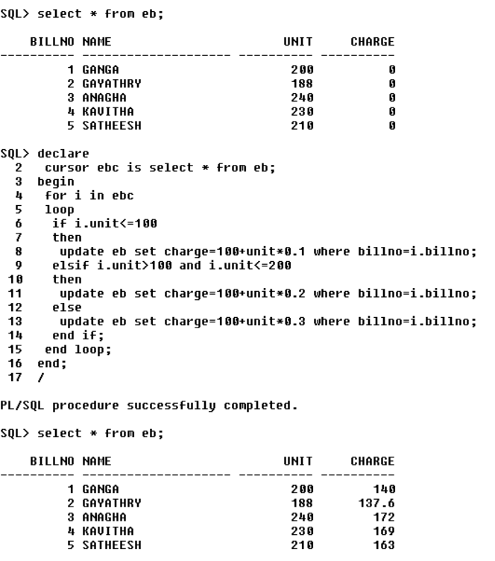

**Output**



1. Write PL/SQL code to UPDATE values in created tables by using Implicit Cursors.

**Program**

create table item(item_id int primary key,item_name varchar(50),item_price int);

insert into item values(&item_id,'&item_name',&item_price);

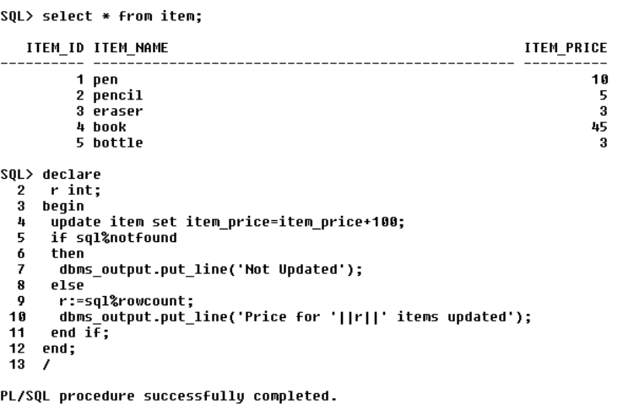

**Output**

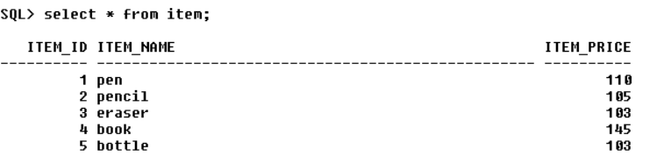

1. Given the table works(emp_id,company_name,salary).write a cursor to select the three highest paid employees from the table.

**Program**

create table works1(emp_id int primary key,emp_name varchar(20),salary int);

insert into works1 values(&emp_id,'&emp_name',&salary);

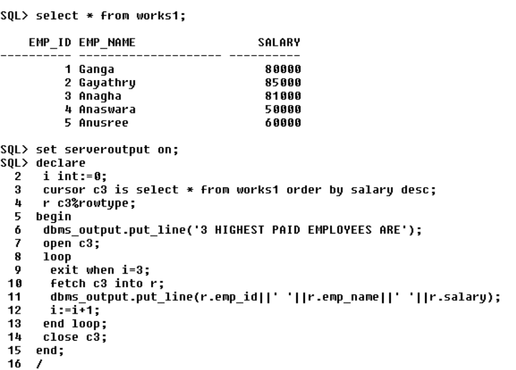

**Output**

